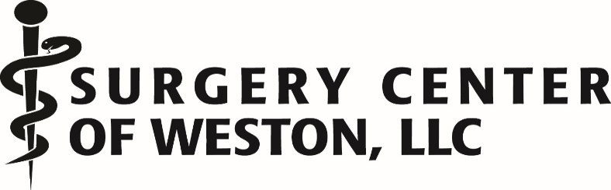

TAX ID# 650933685
NPI 1730124561
APPROVED INSURANCE LIST
AARP
AETNA COMMERICAL
AETNA MEDICARE
AMERICAN PIONEER
AMERICAN PUBLIC LIFE INS COMPANY
AMERIGROUP COMMUNITY CARE
AMERIGROUP REAL SOLUTIONS
AVMED

BANKERS FIDELITY LIFE
BANKERS LIFE & CASUALTY COMPANY
BCBS
BCBS BLUE SELECT
BCBS COMMERICAL
BCBS HEALTH OPTIONS
BCBS MEDICARE ADVANTAGE
BCBS NETWORK BLUE
BCBS TRADITIONAL

CAREPLUS
CHAMPVA
CIGNA
CMS MMA TITLE 21
CMS NETWORK SOUTHEAST
COLONIAL PENN LIFE INSURANCE
COMMUNITY CARE PLAN
CURATIVE

DIVISION OF BLIND SERVICES
DEVOTED HEALTH
DOCTOR’S HEALTHCARE PLANS

EMBLEM HEALTH
EMPIRE

FIRST HEALTH/GEHA
FREEDOM HEALTH

GEHA
GOLDEN RULE
GOLD KIDNEY (ONLY IF PATIENT HAS OUT OF NETWORK BENEFITS)

HEALTHSUN
HUMANA COMMERCIAL
HUMANA MEDICARE
HUMANA PPO

MEDICA HEALTH CARE PLAN (FLORIDA)
MEDICARE
MERITAIN HEALTH
MOLINA HEALTHCARE OF FLORIDA
MULTIPLAN

OSCAR COMMERCIAL ONLY
OXFORD

PHCS
POSITIVE HEALTHCARE FLORIDA
PREFERRED CARE PARTNERS
PREFERRED CARE NETWORK
PREMIER EYE CARE

SANUS HEALTH
SEMINOLE TRIBE OF FLORIDA

TRANSAMERICA LIFE INSURANCE COMPANY
TRICARE SOUTH/PRIME/EAST
TRICARE WPS

UMR
UNITED AMERICAN INSURANCE COMPANY
UNITED HEALTHCARE
UNITED HEALTHCARE GLOBAL
UNITED HEALTHCARE MEDICARE

YORK RISK SERVICES

ZURICH AMERICAN INS CO

OUT OF NETWORK: **REMINDER WE ARE NON-PAR WITH ALL MEDICAID LOB**
SIMPLY HEALTH
GOLD KIDNEY (WE ACCEPT IF PT. HAS OON BENEFITS)
SIMPLY MEDICARE
OSCAR MEDICARE
OSCAR+HOLY CROSS+ MEMORIAL
CIGNA MEDICARE ADVANTAGE
AMBETTER
HUMANA MEDICAID
AETNA BETTER HEALTH OF FLORIDA (MCD)
SOUTH FLORIDA COMMUNITY CARE
STAYWELL
STAYWELL KIDS
AVMED MEDICARE ended 12.31.25sc

